Introduction 4-5 Paragraphs

1. Community structure and role in mineralizing from complex amendments
2. Litter C:N ratio and nutrient availability relationship to copotroph/oligotroph
3. Response to litter is specific to substrates and varies over time
4. Intro to experiment

* Paragraph 1 (4-7 sentences) sustainable nitrogen soil biology
  + Sustainable agriculture has the potential to balance human needs with environmentally beneficial practices, such as the use of composts and leguminous crops to meet the fertilization needs and reduce nutrient losses of cash crops like maize.
  + Soil bacteria play a central role in making nutrients available from high organic matter fertilizers used in these sustainable agroecosystems, yet timing of nutrient availability is challenging.
  + The availability of nutrients in the soil and litter/amendment as well as the native soil community shape the response of the soil bacterial community to high organic matter fertilizers.
  + The complex interaction of soil, chemical and physical factors make predicting the timing of nutrient release from organic fertilizers difficult. In particular, little is known about the different bacterial response initiated in soils from the application of organic amendments.
* Paragraph 2 (4-7 sentences) Depolymerization and community structure
  + The use of C:N ratio of amendment as a predictor of nutrient mineralization has been suggested
* Paragraph 3 (4-7 sentences) Responding bacteria likely depolymerizers
  + Grouping of communities based on time to identify early, likely depolymizers
  + Comparing taxonomic units that are in greater abundance in soils during early and late decomposition.
* Last Paragraph (4-7 sentences) Introduce experiment

Emphasize that we identified bacterial response to organic amendments because there is a knowledge gap regarding specific bacterial response in our system. In addition, bi-augmentation and stimulation are promising points in agriculture that are informed by characterizing the bacterial community (generating targets) responding under different litter/organic amendments

Figures:

1. Phylogenetic bar chart of amendment and starting soils
2. Table of nutrient characteristics (C:N etc)
3. Chemical response over time (Inorganic nitrogen)
4. TSNE ordination
5. Box plot of phyla
6. H clustering (Dendograms)
7. Deseq to identify responders (Amendment responding OTUS)
   1. One for each amendment? With corresponding table to identify taxonomy of OTU
8. Phylogenetic relationship between responders (paulstree)
   1. Could make multiple trees or collapse branches into clades defined by?

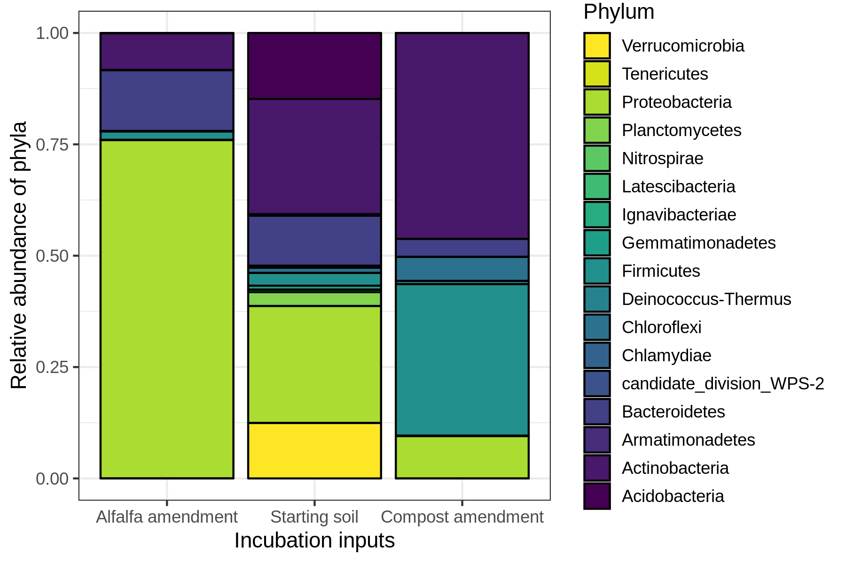

|  |  |  |  |  |  |
| --- | --- | --- | --- | --- | --- |
| **Amendment** | **Mass added** | **% C** | **% N** | **C:N** | **Inorganic N** |
| Alfalfa | 0.8 g | 41.7 | 2.1 | 20:2 | 25.5 |
| Compost | 1.9 g | 33.8 | 1.2 | 29.0 | 13.9 |
| Mix | 1.3 g | 36.2 | 1.4 | 25.1 | Not measured |
| Starting soil | 50.0g | 3.1 | 0.3 | 12.6 | 3.3 |

